M 048
MODEL PAPER
B.Tech. DEGREE EXAMINATION.
Fourth Semester
Chemical Engineering
CH 245 — INSTRUMENTAL METHODS OF ANALYSIS
Time : Three hours Maximum : 100 marks
Answer ALL the questions.
PART A — (10 × 2 = 20 marks)
- What is electrochemical cell?
- What is Saccharimetry?
- What is molecular spectra?
- What is a colorimeter?
- Define electro magnetic force (e.m.f.)
- What is decomposition potential?
- Name any four liquid stationary phase used in GLC.
- Write relationship between atomic number and wave length in XRD.
- What is Elution and Eluent in Chromatographic techniques?
- Define Ohms law.
PART B — (5 × 16 = 80 marks)
- Discuss the principle, instrumentation and application of AAS. (16)
- (a) (i) Write note on GPC. (6)
(ii) Discuss the principle and applications of Polarimeter. (10)
Or
(b) (i) Explain the advantages of DSC over DTA. (6)
(ii) Write brief notes on :
(1) Phase. (2)
(2) Chemical equilibrium. (4)
(3) System. (4)
- (a) Write brief notes on :
(i) Polarimeter. (4)
(ii) Analyzer. (4)
(iii) Plane Polarized Light. (4)
(iv) Dextro Rotatory. (4)
Or
(b) Calculate the expected maximum wave length of absorption for the following compounds in alcohol based on Woodward’s rule.
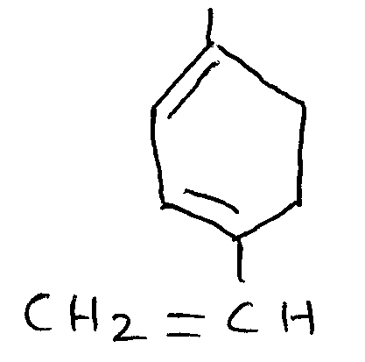
(i)
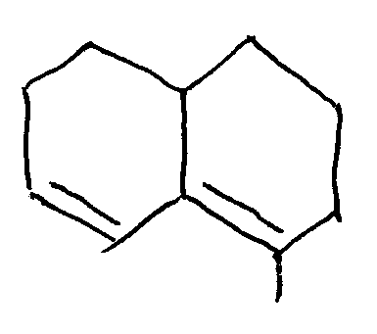
(ii)
- (a) What are the various instrumental factors and samples characteristics that affect the shape of the thermogram.
Or
(b) (i) Write the applications of UV–Visible spectrometry. (6)
(ii) Write any one method to determine the pH of a solution. (10)
- (a) (i) Explain the theory of X–ray spectroscopy. (6)
(ii) What are all the applications of X ray powder crystal method? (10)
Or
(b) Make use of IR spectroscopy to distinguish between the following two compounds.
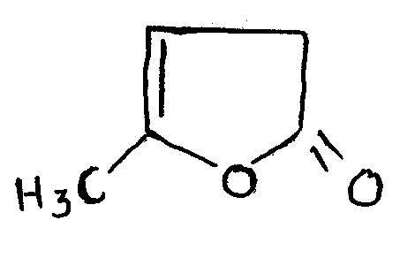
(i)
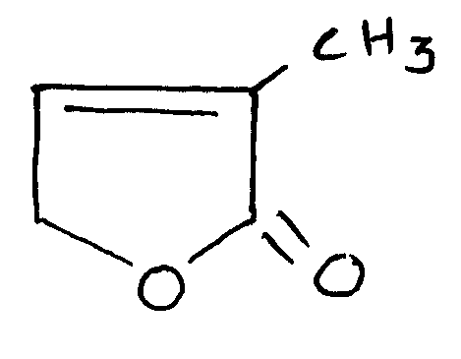
(ii)

———————

